Creating an account in GCP and opening the windows remote desktop.

This is done because to download solarwinds inside the windows server and connect the databases to check its performance.

First troubleshooting issues: I cannot get the remote desktop connection in GCP through instance.

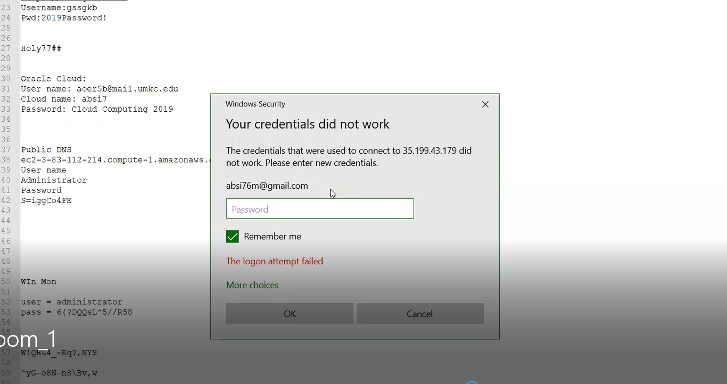

References using some you tubes videos on how to open remote desktop in GCP and some links as follows:

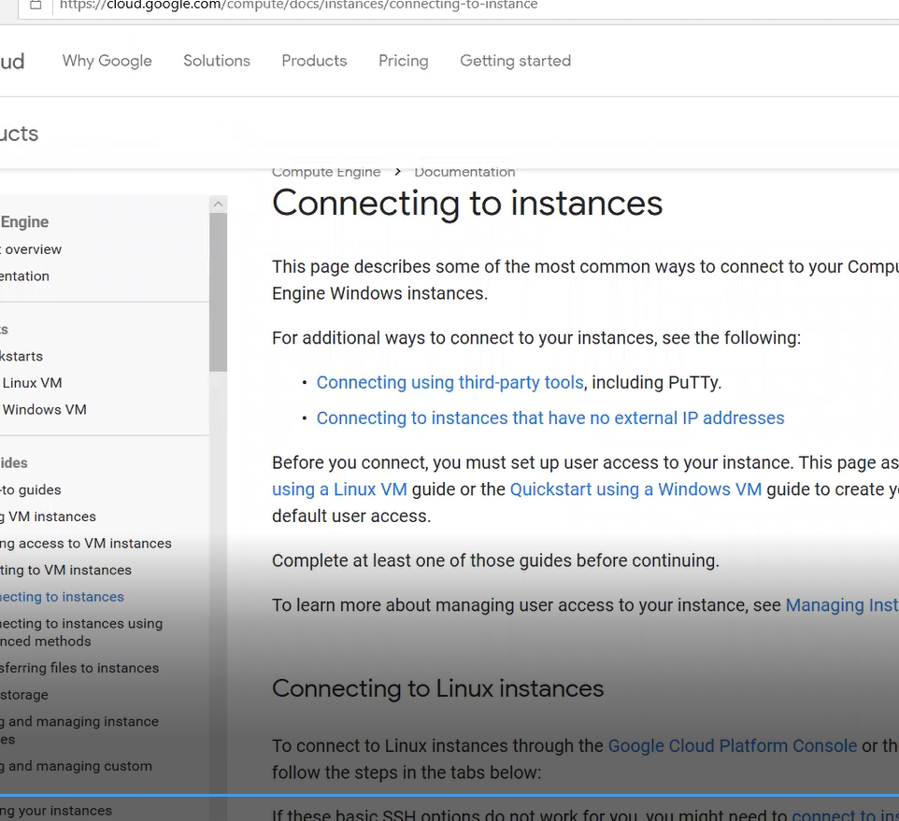

By changing the server from debian to windows server with desktop remote access as follows:

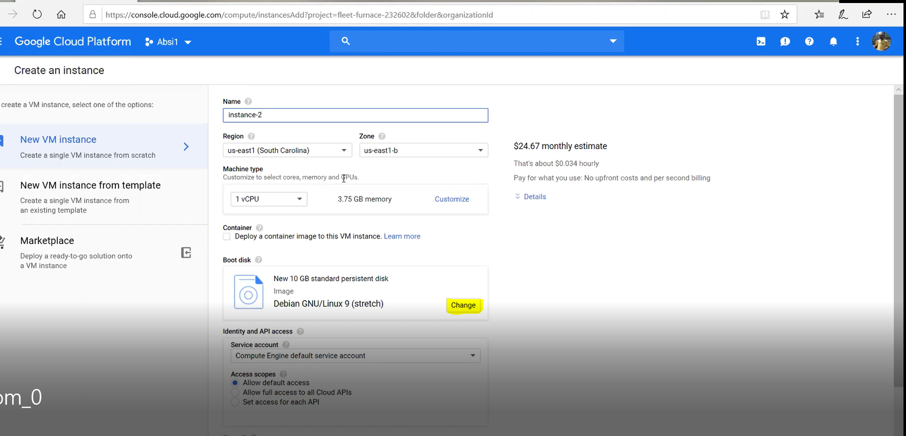

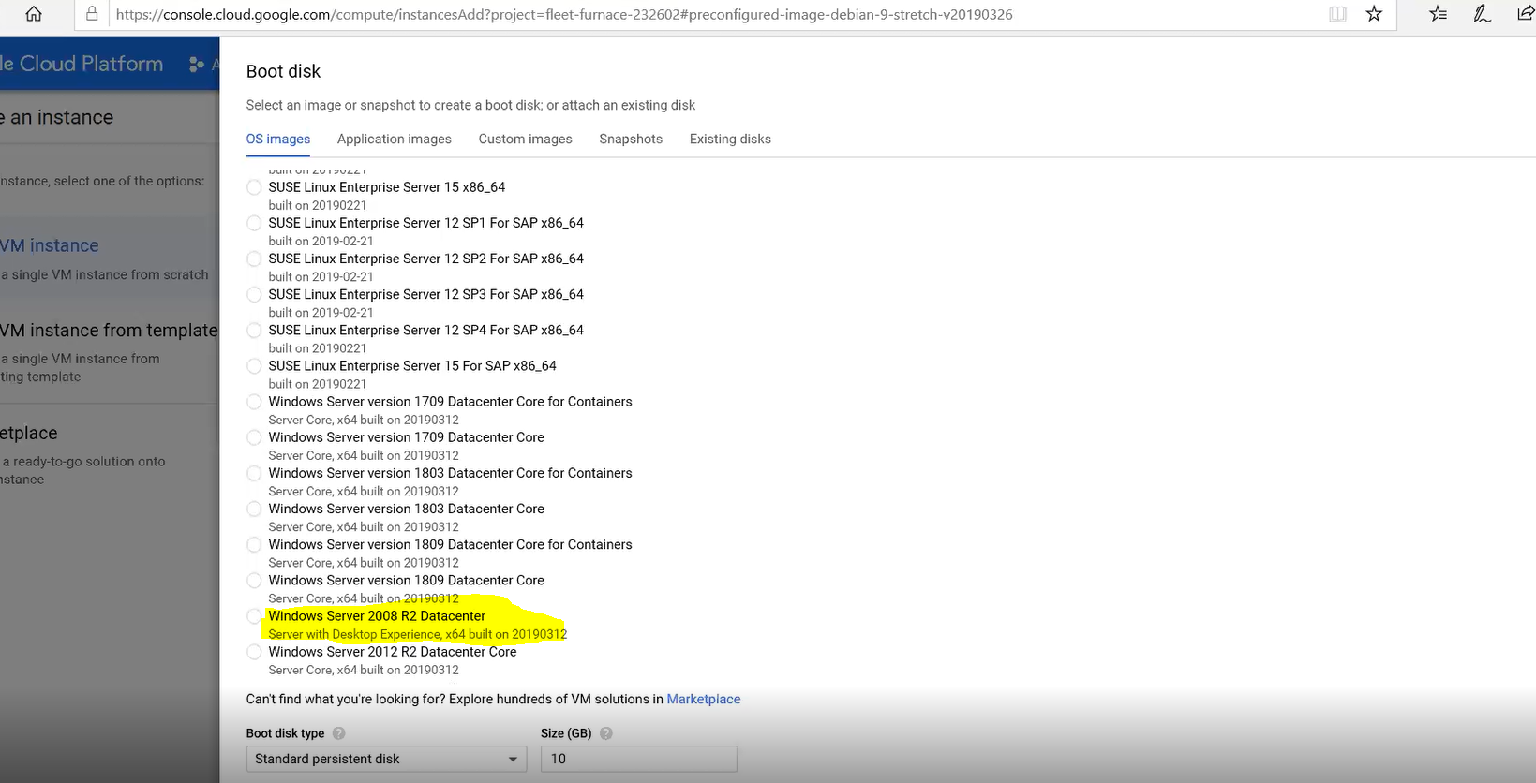

After opening the windows remote server copy the chrome setup and paste it in the cloud VM and run it since the browser in the vm does the security violation :

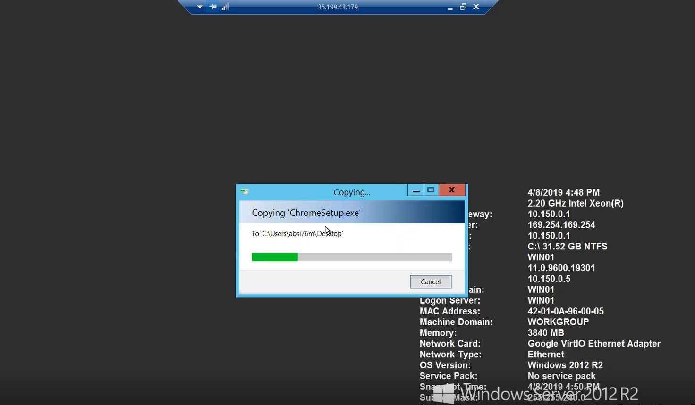

Download repository DB where the analysed data will get stored in the solarwinds repository DB i.e mysql repository community DB will be downloaded and while installing that in the Vm troubleshooting occurs as follows:

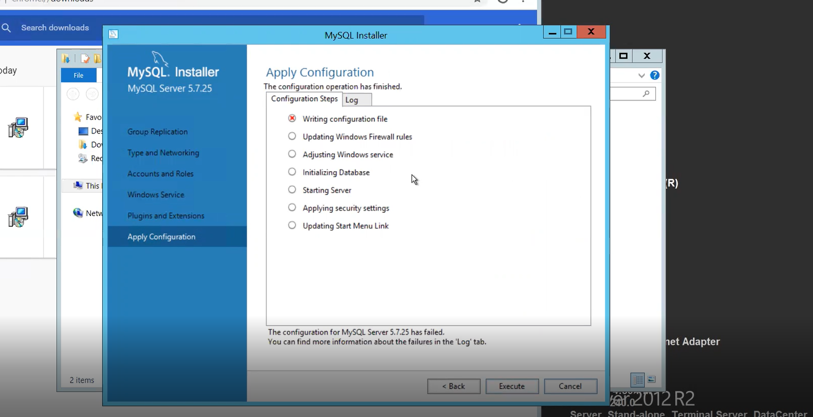

Disabling windows firewall in VM and re install the sql repository it will be executed perfectly as follows:

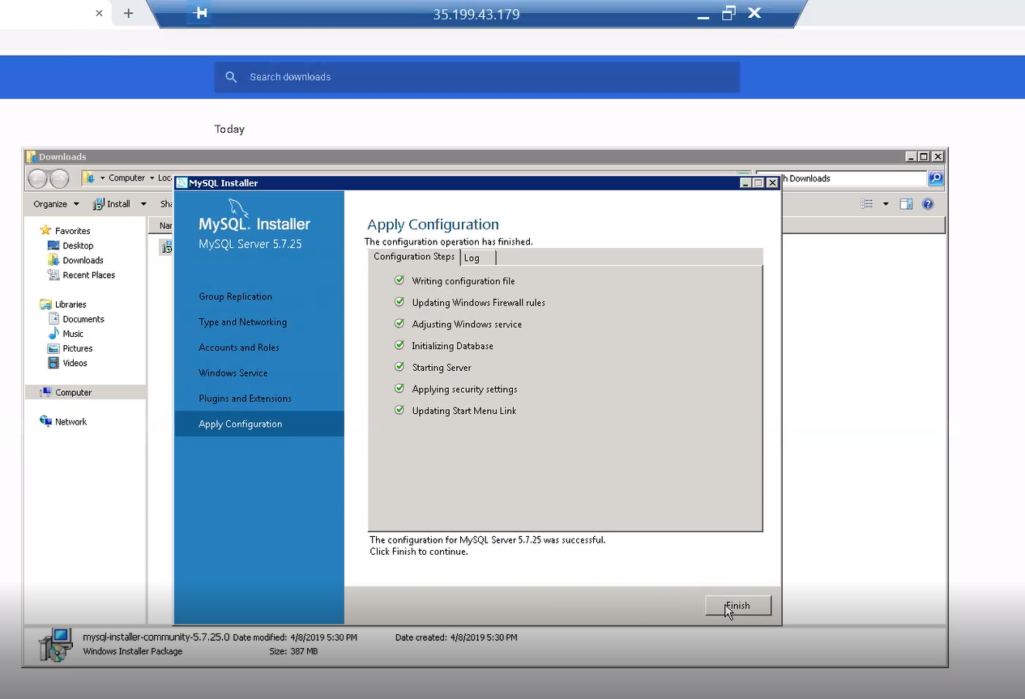

Open the google chrome and start downloading the solarwinds for oracle and start installing that in the VM.

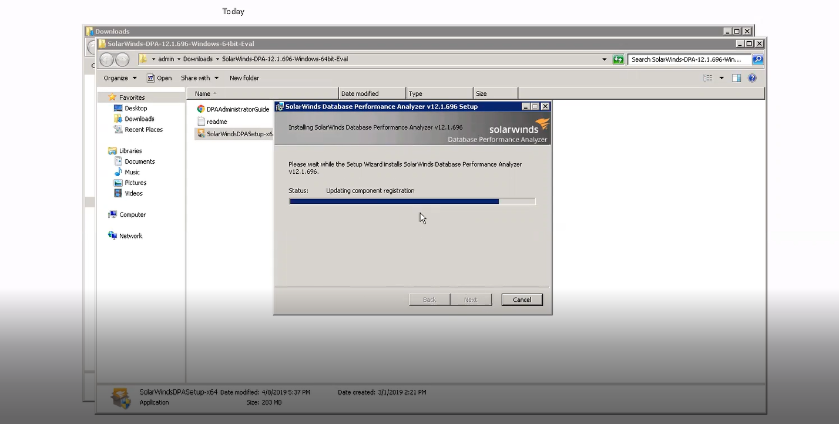

Database performance analyser has been successfully installed in GCP VM as follows:

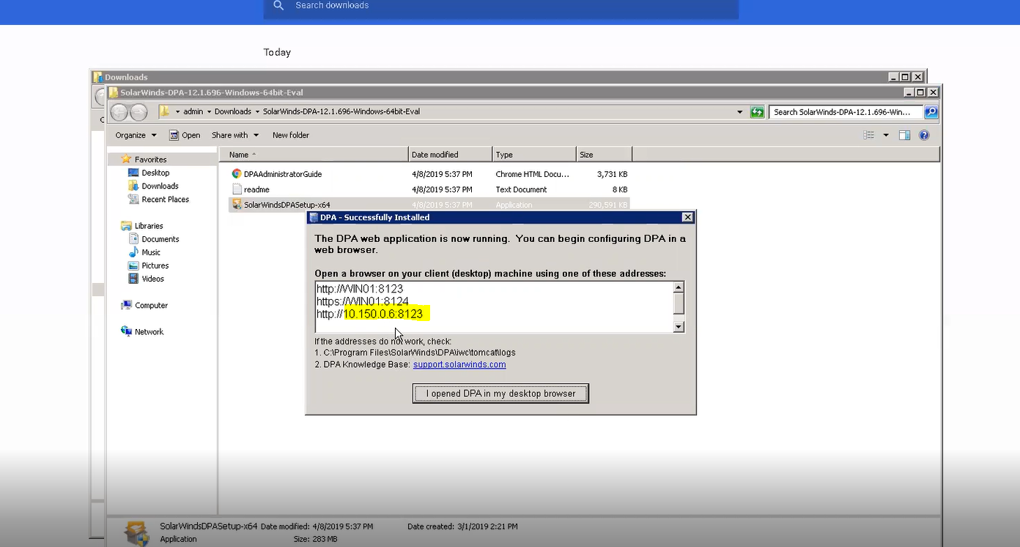

Make note of the port and open a browser and give the port in the browser then the solarwind will open as follows:

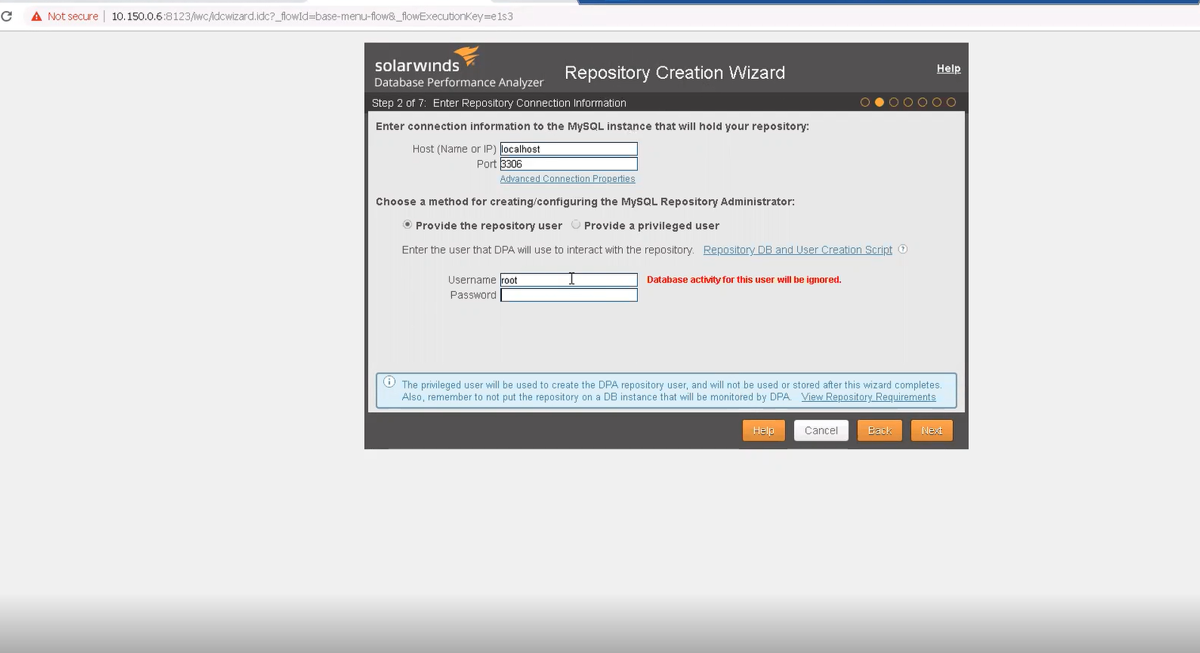

Using the command prompt change the directory and execute the solarwind and your Database DPA will be created inside the solarwind.

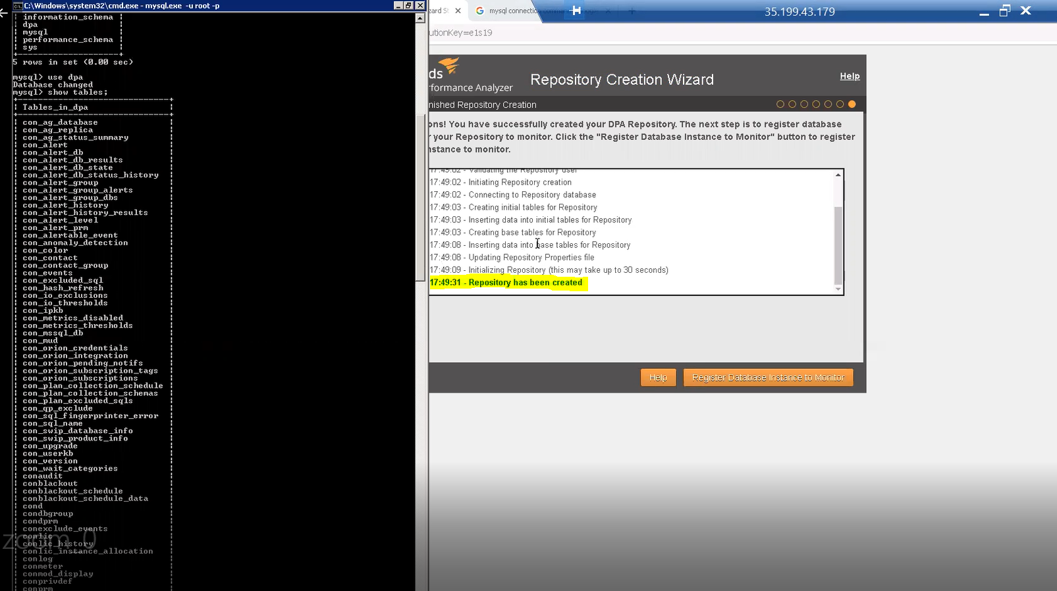

Now connect the aws Database to Gcp solarwind.

Open the aws console and ping the gcp public ip it will be connected as follows:

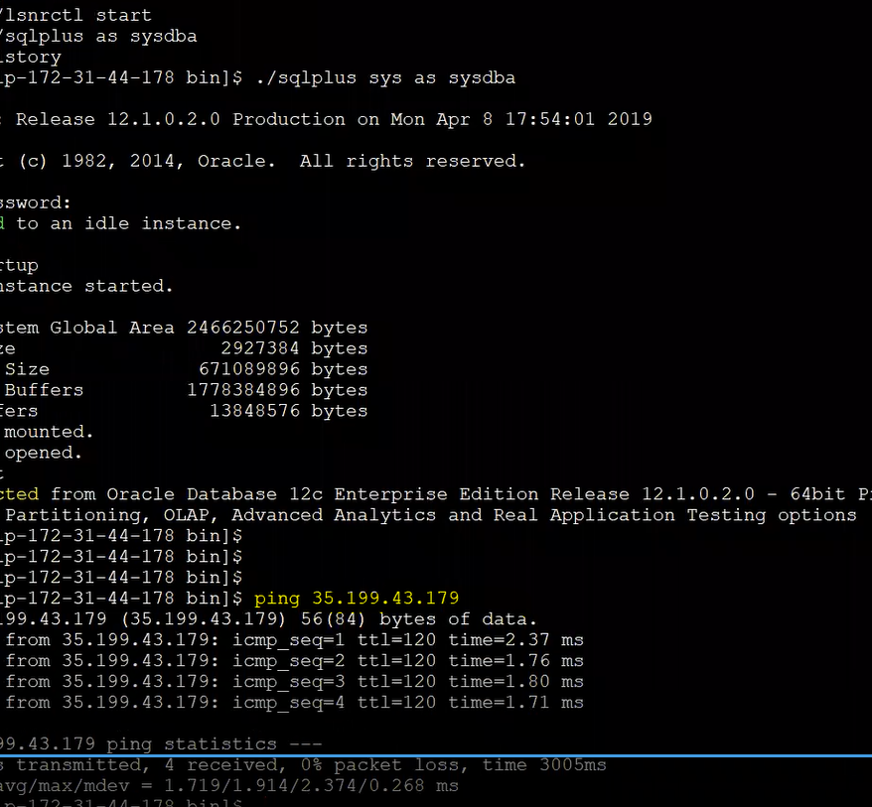

But the gcp does not ping because of firewall rules and we need to add a new rule and then configure telnet and establish the connection.

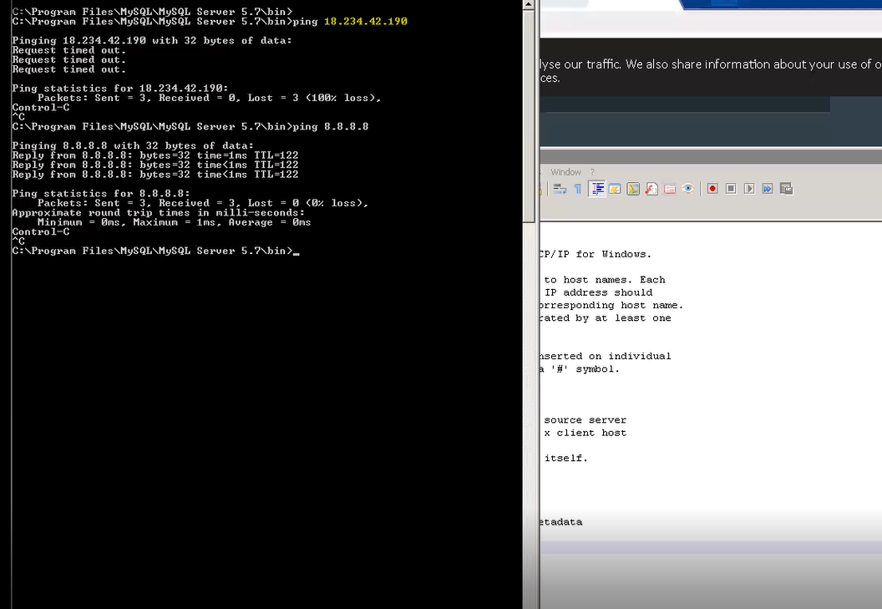

Enabling firewall rule in GCP:

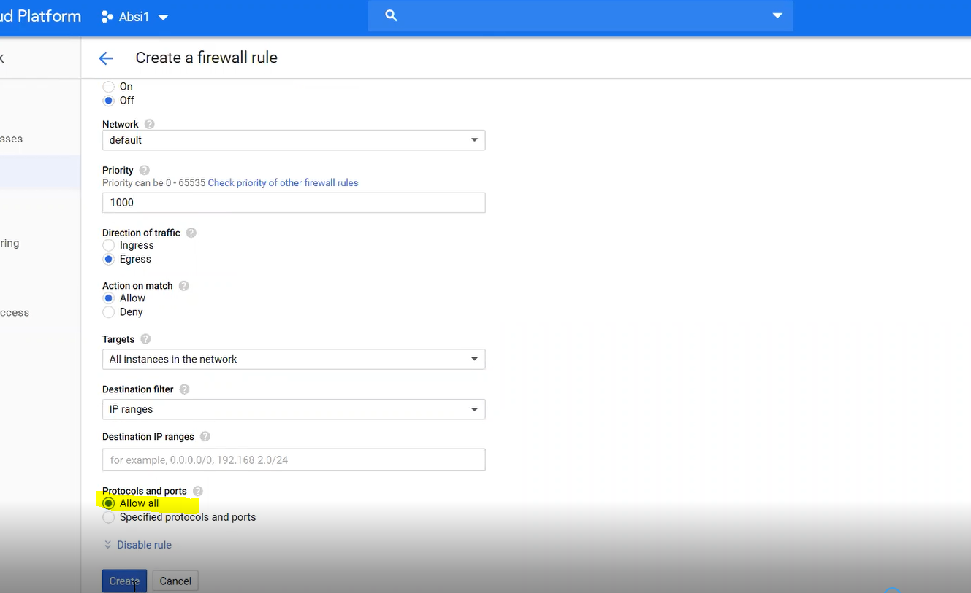

In gcp aws is connected through telnet as follows:

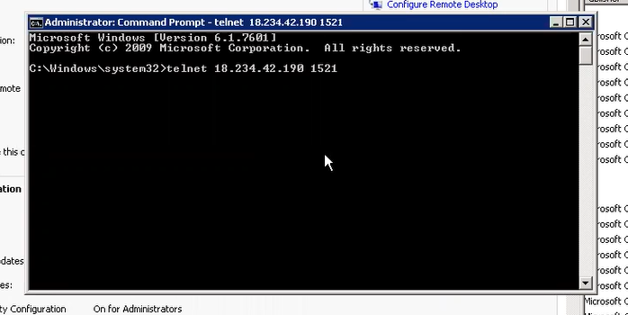

Connect the database in solarwinds there comes another issues:

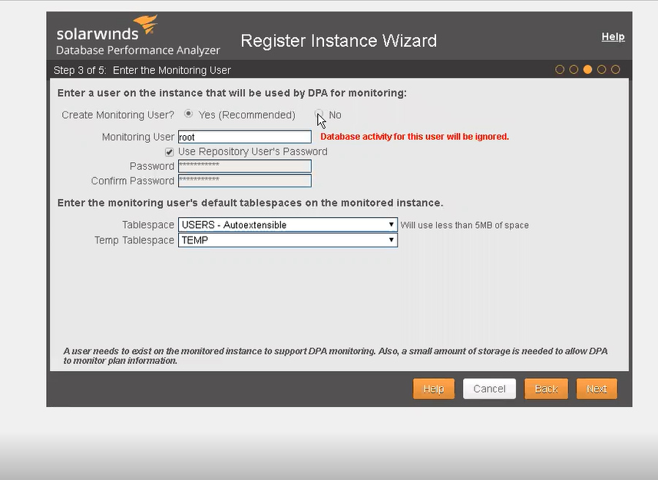

By creating the monitoring user and password aws database has been successfully registered.

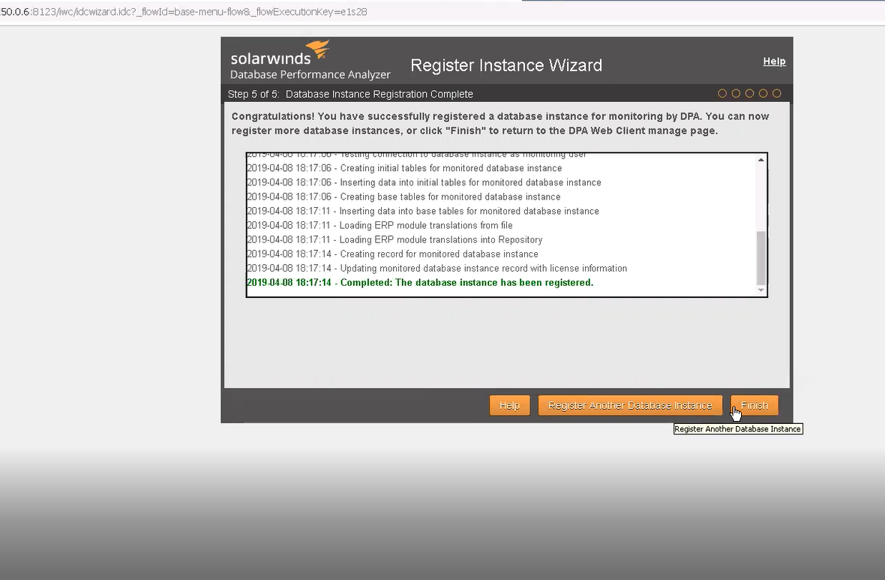

Thus solarwind is created in GCP and aws is registered as follows:

